JOHANA POCKOVÁ, SABINA BOČKOVÁ & INGA ZOTOVA – MIKSHINA

TREATMENT OF REMEMBERING

live music by Lukáš Palán

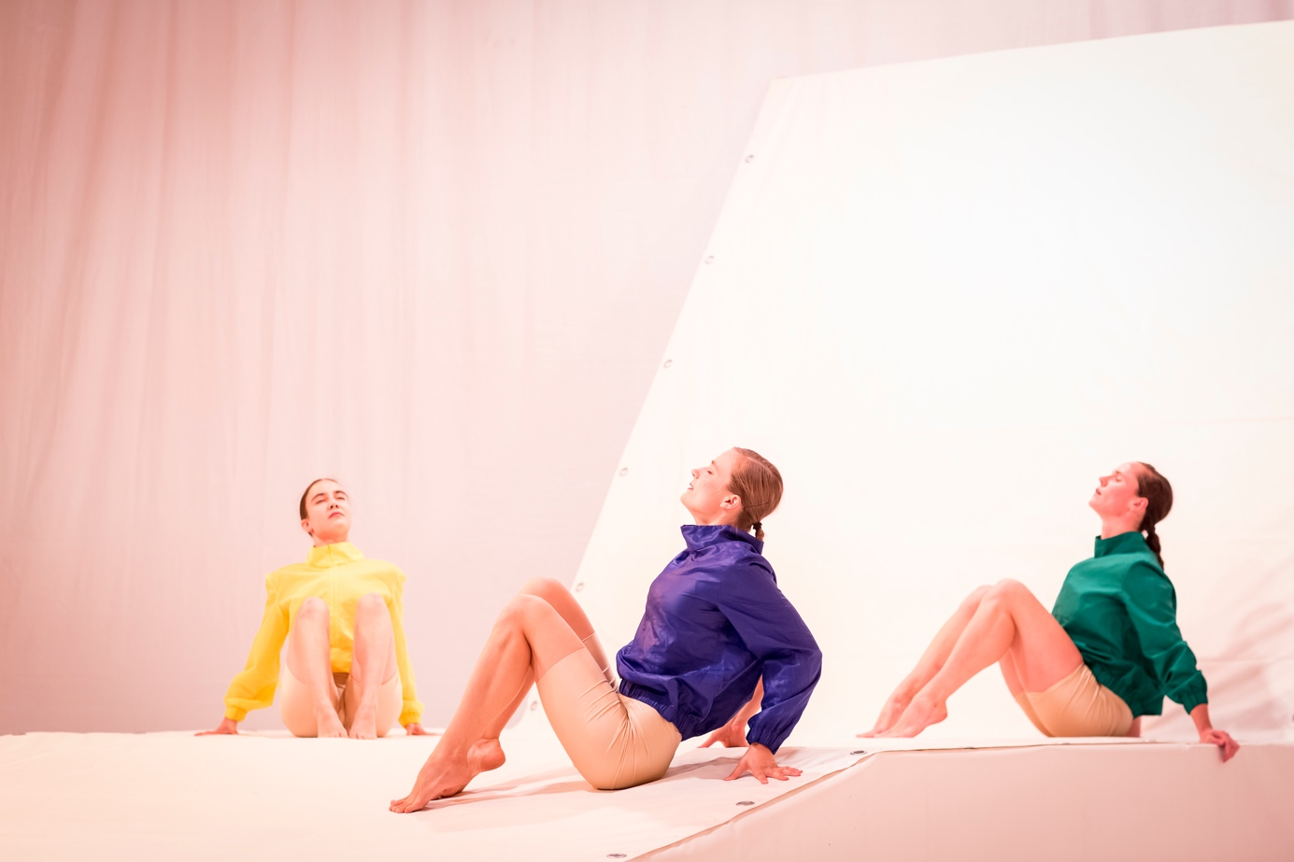

photo credits: Vojtech Brtnicky

* …“Perhaps this performance might mean for the Czech contemporary dance to finally exceed the curse of its own shadow from the second half of the 20th century.“ *Zuzana Smugalova, Czech Dance News*
* Premiere: 5.10. 2020, Ponec – dance venue, Prague
* The performance Treatment of Remembering won **the Czech Dance Platform International Jury Award 2021, the Czech Dance Platform Audience Award 2021 and got the 1st Dance News Award** for the originality of the concept. Treatment of Remembering is also part of the **AerowavesTwenty22 selection**. The performance **toured nationally in the Czech Republic as part of the festival TANEC PRAHA 2021**, it was presented as part of the **BAZAAR festival in Prague, MOVE fest Ostrava, Czech Dance Platform, Spring Forward Elefsina (GR), NU Dance Fest Bratislava (SK), Danza Estate festival Bergamo (IT), IN2IT Dance Festival (NO), Obnazeni festival and others**. It is performed regularly in PONEC – dance venue in Prague.
* Treatment of Remembering was so far presented more than 30 times (the premiere happened a just a week before a lockdown in Czech Republic) in various forms: the premiere at the PONEC – dance venue, two work in progress presentations at the BAZAAR Festival 2020 and in the Plum Yard theater in Malovice and two outdoor presentations of a shorter version within the project Lungs of Žižkov and Lungs of Žižkov - Second Breath.
* During spring 2021 the piece has been **re-worked for the outdoors version (more info below)**. Since then, it has been performed in different outdoor and indoor spaces.

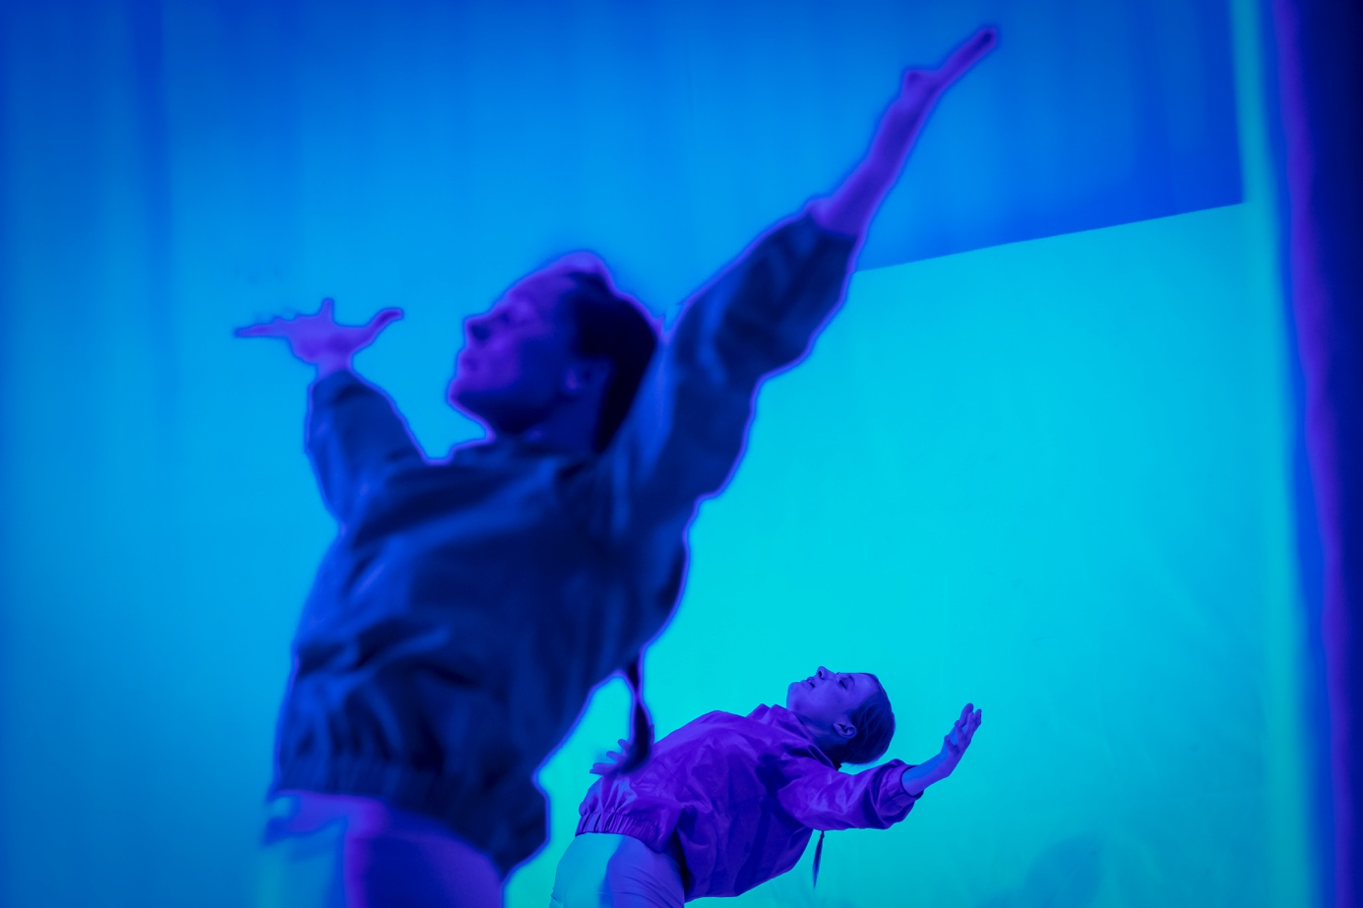

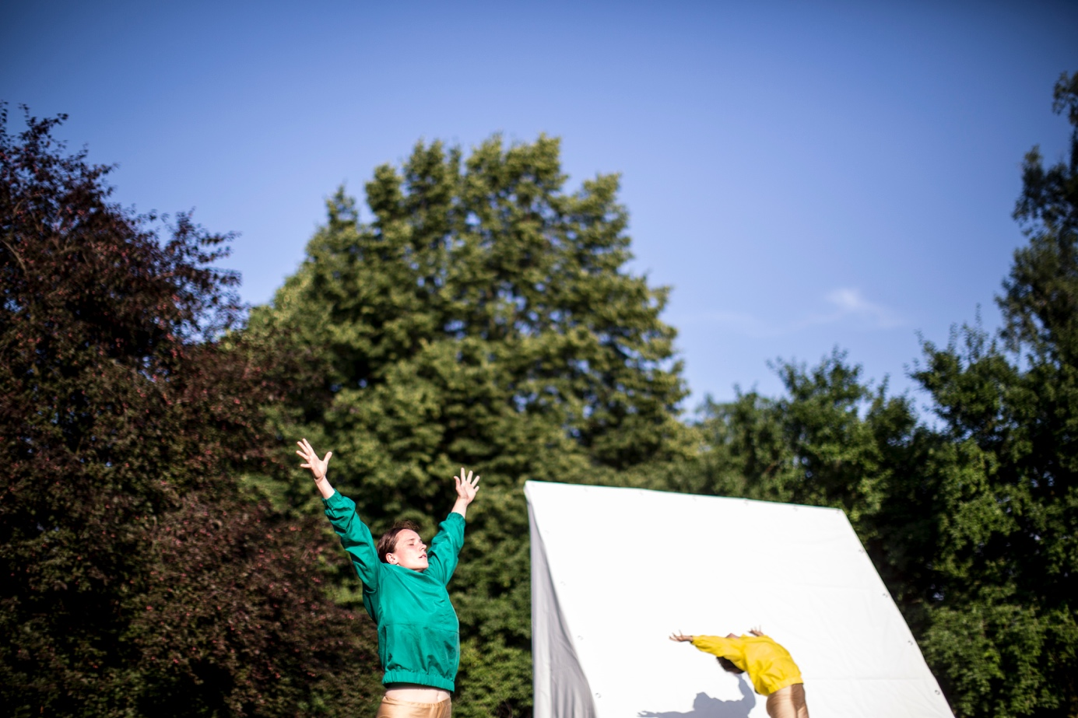

photo credits: Vojtech Brtnicky

Abstract

‘Imagine yourself breathing.’

Three performers undergo a procedure “Treatment of Remembering“ together with the audience in a time when nature, consumed by humanity, no longer exists. In poetic dance paintings, they fall into a state of remembering nature in an emptied space-time. Through the artificial imitation of the world, which has pushed out the real world, they point to the ever-increasing replacement of the natural environment with the artificial products of human activity. By awakening memories of long forgotten experiences, the treatment of remembering procedure draws attention to the uniqueness of physical and emotional experiences connected with nature. The sensitivity of sound design and original music, together with extreme light atmospheres, enhance the intensity of sensory perception and thus complement a work filled with a constant vibration of origin and extinction. Yet from the artificially created atmospheres of calm emerge strong concerns, encouraging the viewers to reflect on their own relationship with the environment.

Practical information

Credits

Concept, direction, creation: Johana Pocková, Sabina Bočková, Inga Zotova-Mikshina

Performing: Johana Pocková, Sabina Bočková, Barbora Dimmock/Inga

Zotova-Mikshina

Music: Lukáš Palán

Sound design: Jakub Štourač

Set design: Denisa Švachová

Light design: Michal Horáček

Dramaturgical support: Petra Hauerová

Technical support: Daniel Rollo/Tomáš Knapek

Produced by: POCKetART z. s.

Co-produced by: Tanec Praha, PONEC – dance venue

Financially supported by: Ministry of Culture of The Czech Republic, State Culture Fund of The Czech Republic, Prague City Hall

Supported by: BAZAAR Festival, Plum Yard Malovice, REZI.DANCE Komařice, Moving Station Plzeň

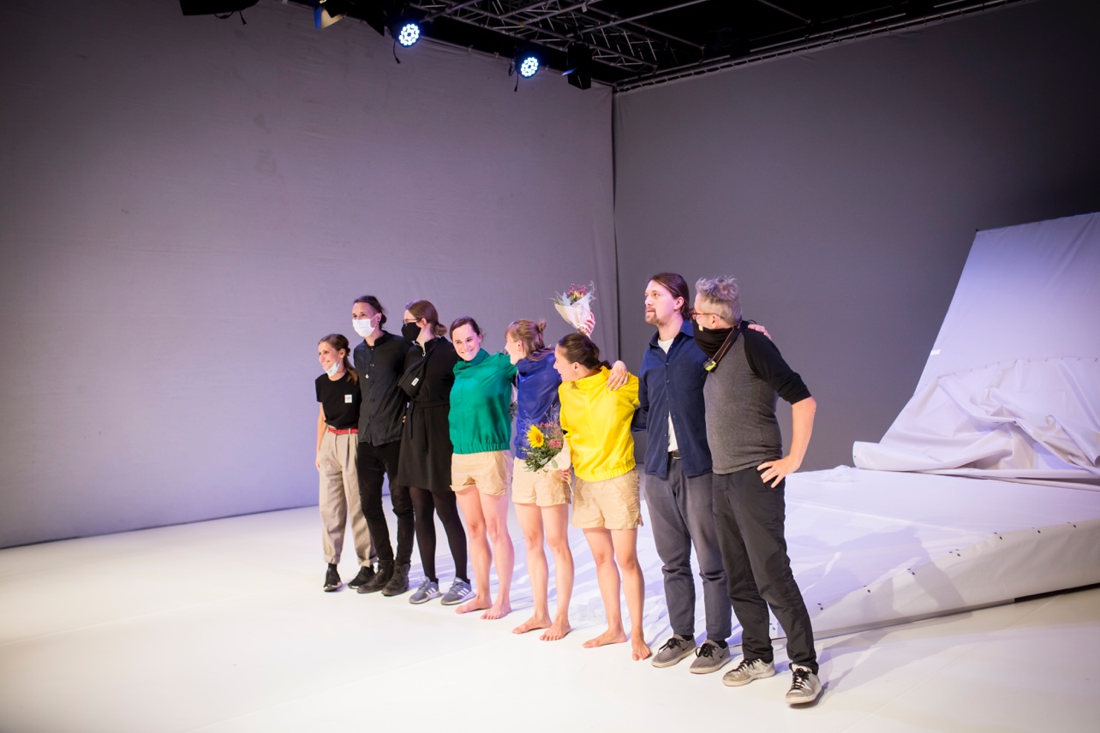

Tour

Duration: 40 minutes

Headcount: 6 people - 3 performers / musician/ light designer / technician

Set up: day before show ideally

Stage dimensions: w/d/h – 12/6/6

Video

Full lenght theater version: <https://vimeo.com/719602997/c0cf2e25d5>

Teaser: <https://vimeo.com/719600457>, <https://vimeo.com/719602395>

Photo

<https://drive.google.com/drive/u/0/folders/1LeFM9VQdL3SZii8QZDBFt6OPZBBc2Xwb> credits: Vojtěch Brtnický

Technical rider

stage

minimal stage size 8m widht x 10 m depth

distance of truss to stage is 6 m, flying bars of truss system must be empty

white box (white horizont and white sides)

whole stage covered by white marley

sound

PA system matching venue size including subwoofer, 4 monitors hanging from the seiling or on statives

6 channel mixer with faders and jack inputs

1x Dynamic microphone with switch button

1x microphone stand

1x table 30x20 + chair

8x socket

light plot

<https://docs.google.com/document/d/1DLYhurH8FGWxJJlpvlmKX3qO4D7qa8G6BuenAZMTHmw/edit?usp=sharing>



Reviews

… “As determined for this current premiere, the author's tandem remains functional. They did not abandon their personality in the path of a choreographic style based on the rhythm of movement expression and imaginative sharing of individual impressive perceptions, which is a prime example of a possible contemporary form of Central European stream of expressive dance east of paradise in the parallel universe of the German dance theater. “……“Perhaps this performance might mean for the Czech contemporary dance to finally exceed the curse of its own shadow from the second half of the 20th century.“

“… The choreography Treatment of Remembering does not go the way of engaged and screaming provocation, but rather forces deeper thinking. This corresponds to its meditative flow, using movement minimalism, which depicts the course of the process of remembrance and contrasts sharply with rhythmic expressiveness demonstrating the power of the importance of selected memories.”

“Imaginations are not descriptive, but they are not directly abstract, their expression is determined by the dynamics of the performance. In the end, the concreteness is evoked only is words, which are deepening the catharsis of the work and thus strengthening the emotional reverberation of the whole stage action. Both for the protagonists and the audience. "

*Zuzana Smugalová, Czech Dance News*

link: <https://www.tanecniaktuality.cz/recenze/expresivni-imaginace-treatment-of-remembering>

"The theme of remembering the ruined and long-forgotten pure nature sounds more than current. "..." Well-functioning sterile minimalist scenography, together with original music, subtle sound design and light design, conjured a state of weightlessness together."

*Natálie Paulasová, Opera+*

link: <https://operaplus.cz/terapie-rozpominanim/?fbclid=IwAR1HpObpgHEiCDKPdSVcUnxzNeN9MY10tD97P1eg65lPpvmUWe6o0ph40cI>

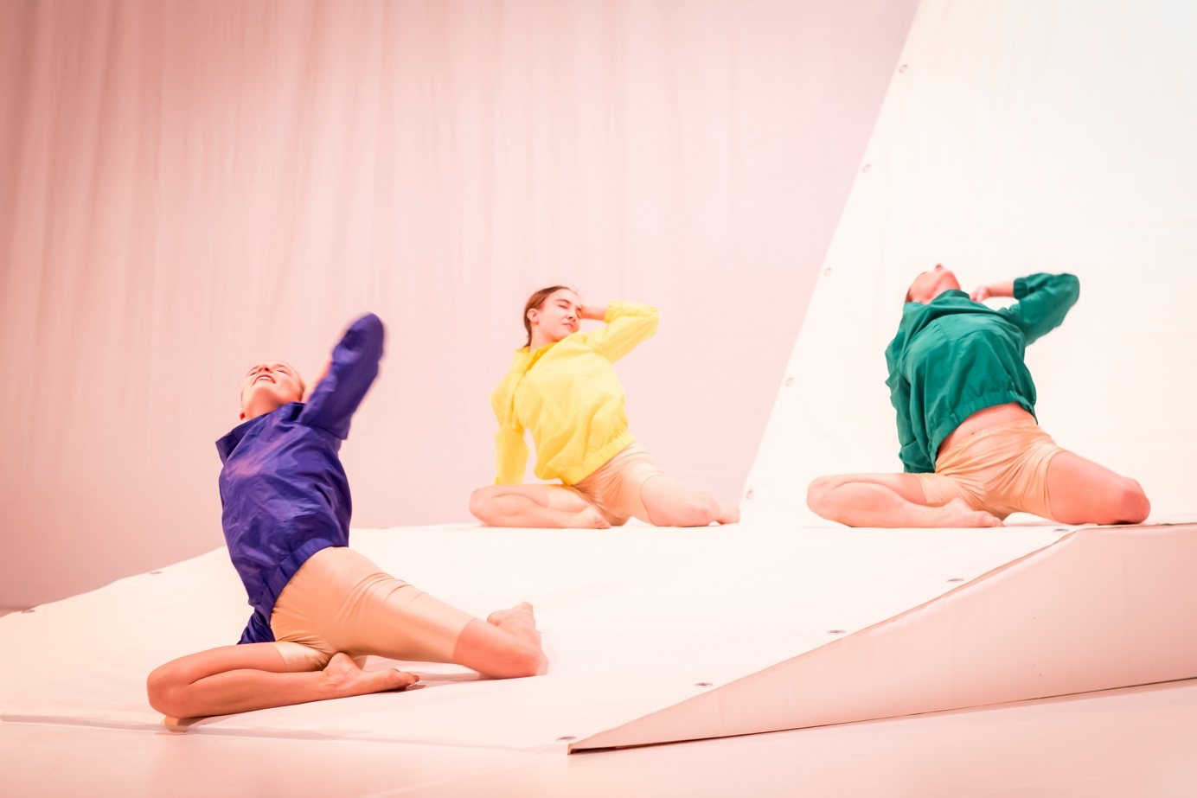

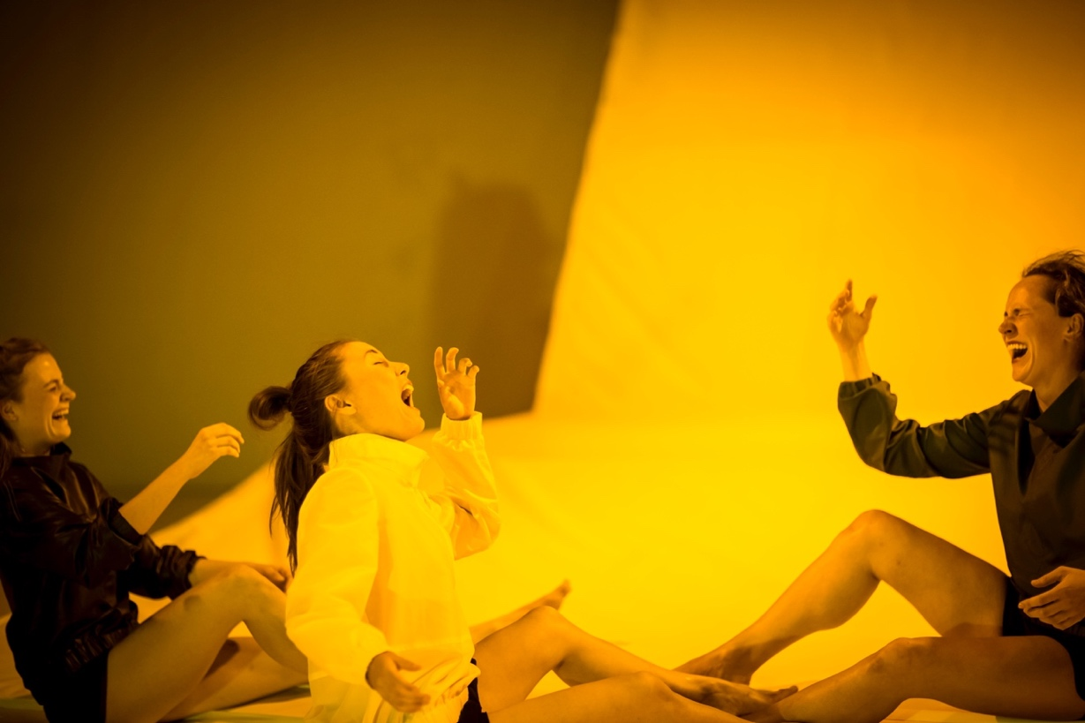 photo credits: Vojtech Brtnicky

TREATMENT OF REMEMBERING OUTDOOR

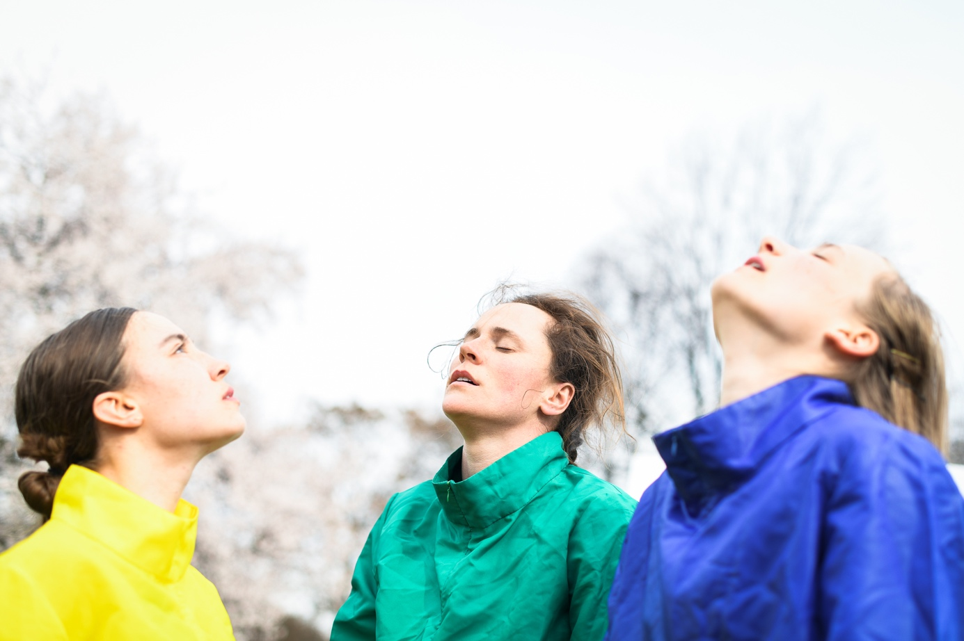

photo credits: Michal Hančovský

Abstract

“Imagine yourself breathing.”

Three performers undergo a procedure “Treatment of Remembering“ together with the audience in a time when nature, consumed by humanity, no longer exists. In poetic dance paintings, they fall into a state of remembering nature in an emptied space-time. Through the artificial imitation of the world, which has pushed out the real world, they point to the ever-increasing replacement of the natural environment with the artificial products of human activity. By awakening memories of long forgotten experiences, Treatment of Remembering procedure draws attention to the uniqueness of physical and emotional experiences connected with nature. The sensitivity of sound design and original music enhance the intensity of sensory perception and thus complement a work filled with a constant vibration of origin and extinction. Yet from the artificially created atmospheres of calm emerge strong concerns, encouraging the viewers to reflect on their own relationship with the environment. The outdoors version of the original theater piece Treatment of Remembering creates a tension between artificially created sterile scenography and the living environment which surrounds it.

Intention

The performance is an artistically processed contribution to a public discussion on the currently alarming topic of the extinction of nature due to human activity.

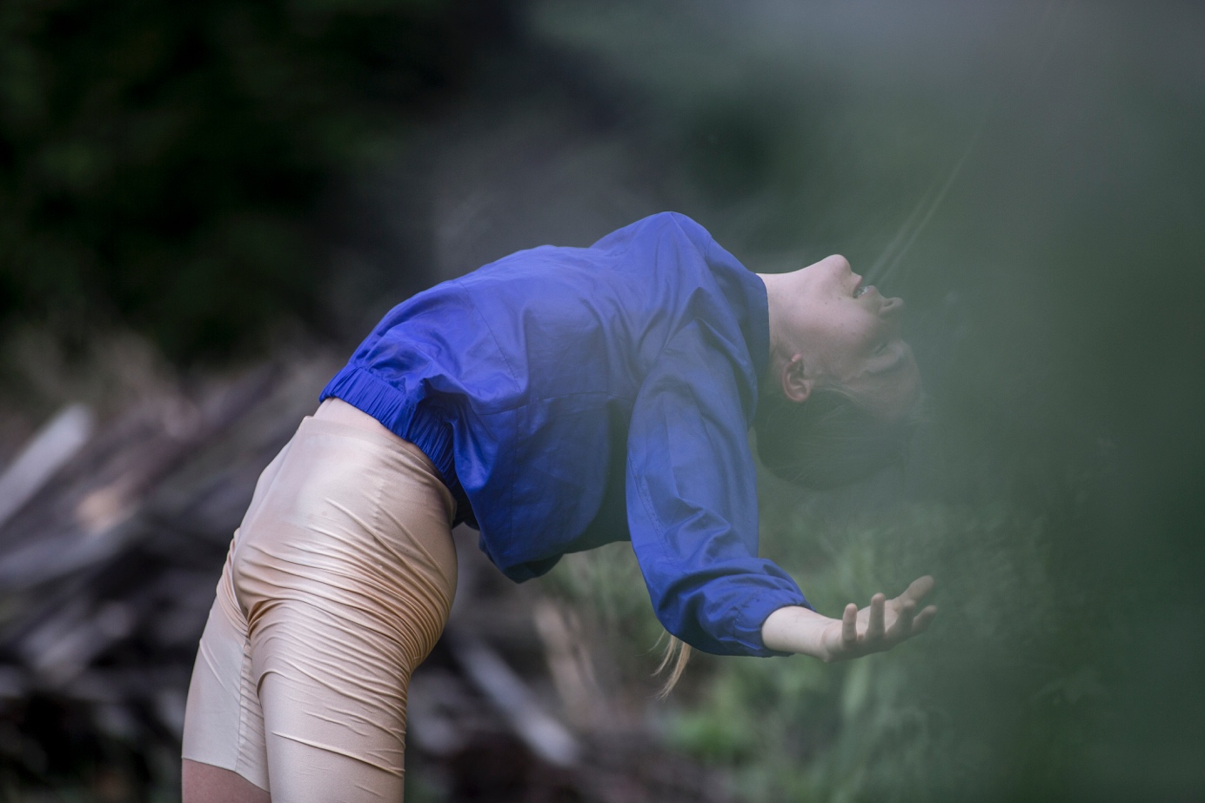

photo credits: Vojtěch Brtnický

Practical information

Credits

Concept, direction, creation: Johana Pocková, Sabina Bočková, Inga Zotova Mikshina

Performing: Johana Pocková, Sabina Bočková, Inga Zotova-Mikshina/Barbora Dimmock

Music: Lukáš Palán

Sound design: Jakub Štourač

Set design: Denisa Švachová

Light design: Michal Horáček

Dramaturgical support: Petra Hauerová

Technical support: Daniel Rollo/Tomáš Knapek

Produced by: POCKETART collective

Co-produced by: Tanec Praha in collaboratin with GHMP, PONEC – dance venue

Financially supported by: Ministry of Culture of The Czech Republic, State Culture Fund of The Czech Republic, Prague City Hall

Supported by: BAZAAR Festival, Plum Yard Malovice, REZI.DANCE Komarice, Moving Station Plzen

Video

Full show outdoors version: <https://vimeo.com/552928825/5385804f3f>

Teaser: <https://vimeo.com/719600457>, <https://vimeo.com/719602395>

Photo

<https://drive.google.com/drive/u/0/folders/1_LXL_bEF_cg-4vhpAjLWAxFA1IOjvKnO> credits: Vojtěch Brtnický

<https://drive.google.com/drive/u/0/folders/1Kqaomp0-WD56ehcDU-frmXFkJq7Jxihw> credits: Michal Hančovský

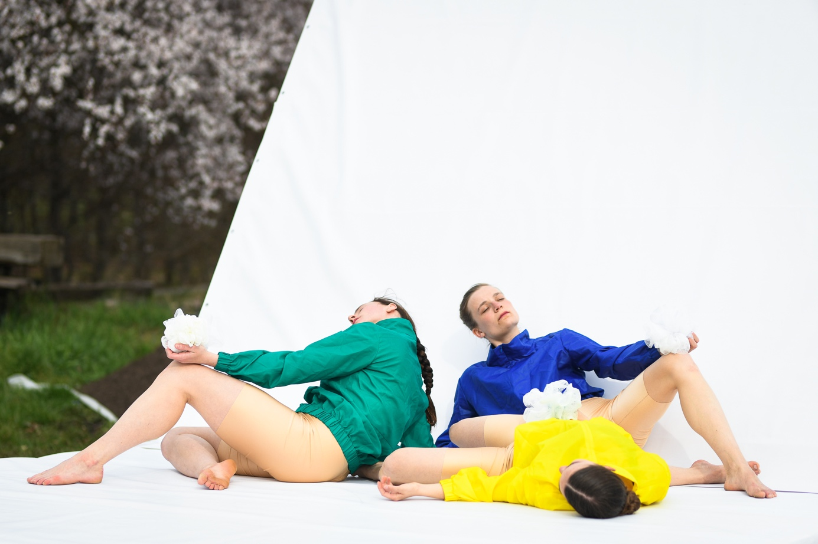

photo credits: Michal Hančovský

Technical rider

location:

* flat natural open spaces (meadows, parks, forests, castle gardens,..)
* also possible to perform on a 10m x 10m outdoors stage covered by white marley

sound:

* PA system matching venue size including subwoofer, 2 monitors on statives
* 6 channel mixer with line inputs (for jacks)
* 1x microphone stand
* Dynamic microphone with switch button
* 1x table 30x20 inches + chair
* 8x sockets

lights:

the outdoor presentation has two versions:

1. version withnout lights in daylight
2. version with minimal light design according to the possibilites of the venue

POCKETART collective

POCKETART collective is an **internationally acclaimed team of creators working in the field of contemporary dance and physical theater** under the direction of the **choreographers Sabina Bočková and Johana Pocková**. As part of its projects, the team brings together artists from the fields of dance, music, scenography, fine arts, and light design. Their work has toured internationally in Europe, Africa and South America, their pieces have been part of **Aerowaves Twenty21 and Twenty22** and presented at various festivals including **Tanzmesse 2022**. With their works they are part of **European projects** such as **Shape it!** and **Big Pulse Dance Alliance**.

The work of the team is characterized by tackling topics that go beyond the personal experience of the individual and touch upon societal issues such as manipulation through media, global environmental threats, stress in a competitive environment, or the position of an individual in the corporate work system. The creators try to approach these topics comprehensively through detailed work with all theatrical components. For each of their works, they always look for a new stylization of physical expression unique to the topic at hand, creating dance images from specific body references. Through their distinctive poetics, visual purity and strong original music, the performances aim to give birth to a spiritual experience, compelling the audience to reflect on our society.

Contact

email: pocketart50@gmail.com

phone number: +420776600356, +420775375416

[www.pocketart.cz](http://www.pocketart.cz)

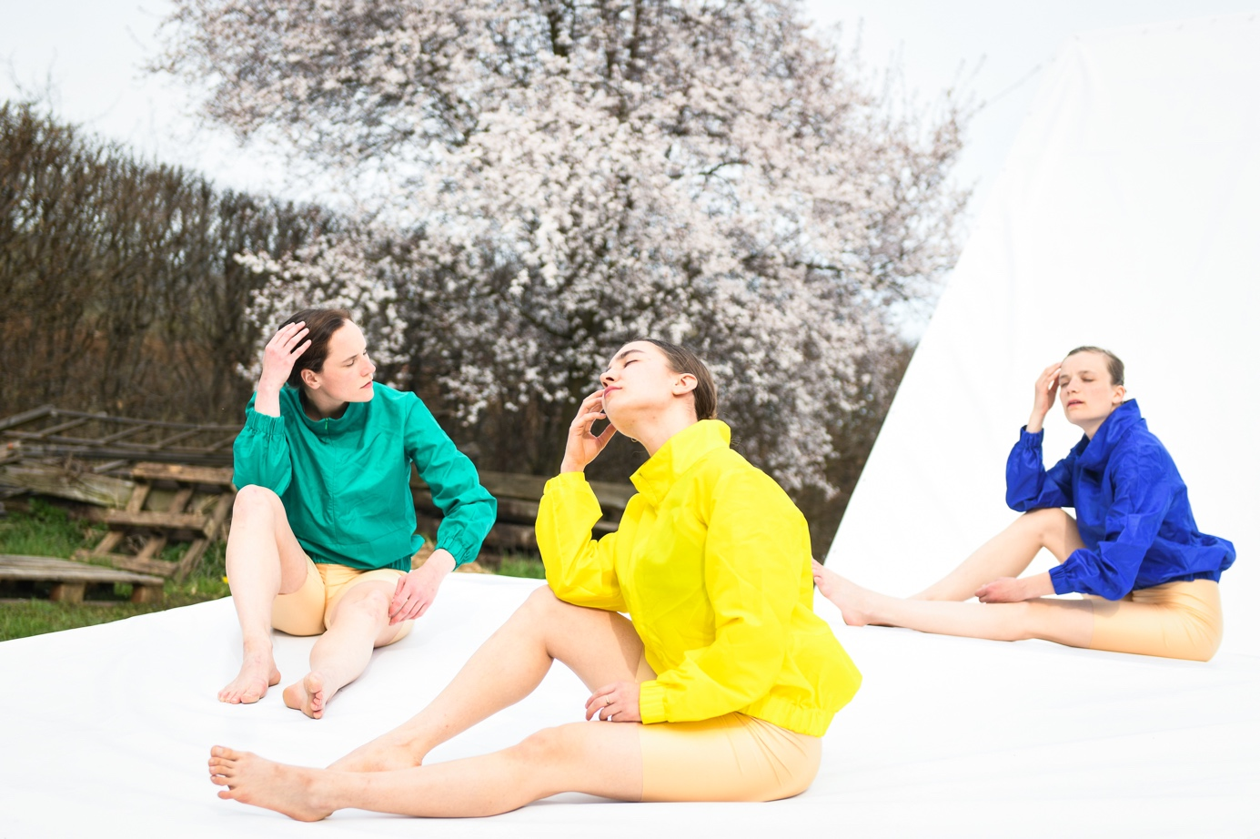

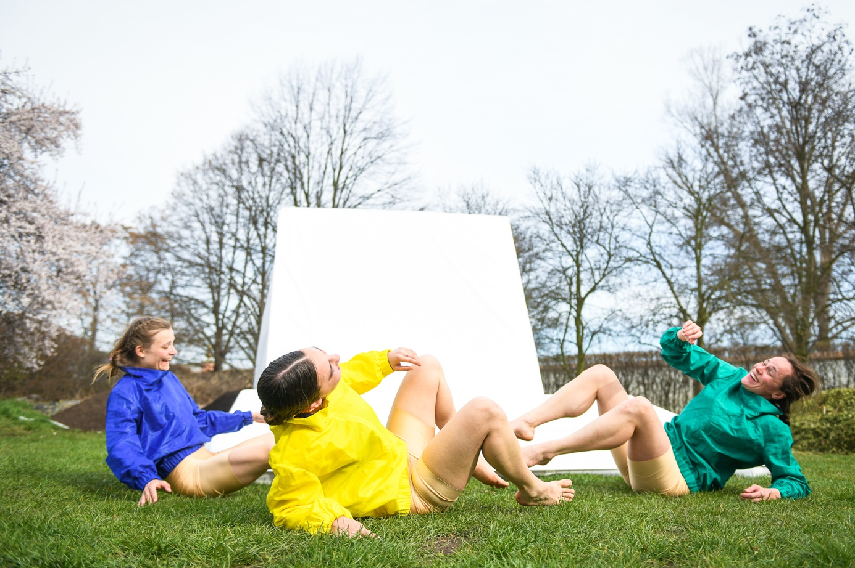photo credits: Michal Hančovský

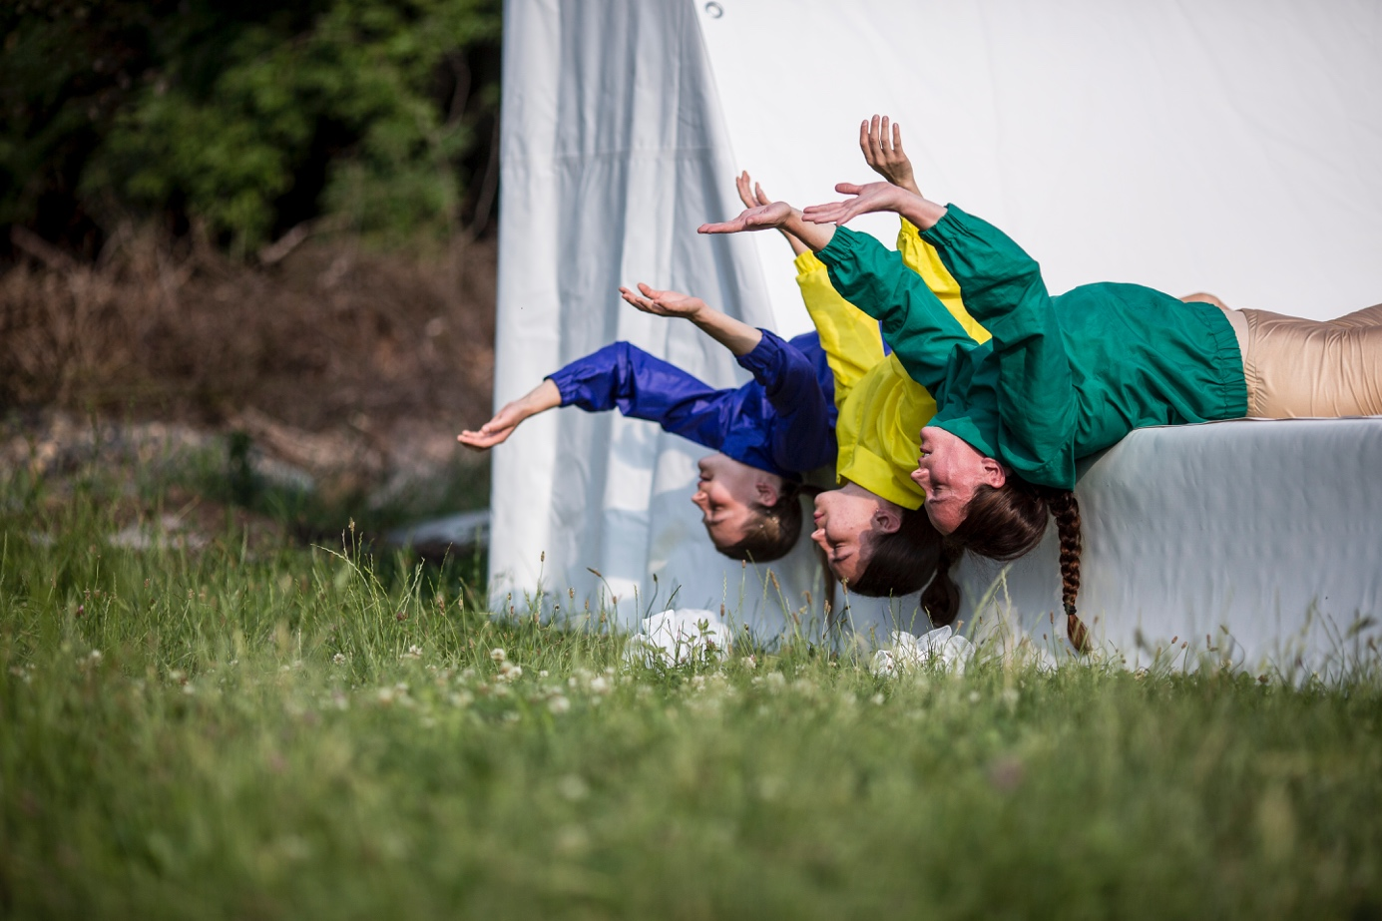photo credits: Vojtěch Brtnický